**Progress Report (PHY:496 - Summer 2024)**

**VENKATA SESH TEJ MATTA : (10 Weeks – 06/17/2024 – 08/24/2024).**



# **Timeline**

| **S. No.** | **Week** | **Date** | **Tasks** |
| --- | --- | --- | --- |
| **1** | **1-2** | **06/17/2024** | **Ran the existing notebooks, setting up environments and debugging the code for clarity.** |
| **2** | **06/24/2024** | **Understanding the codes and getting it running in google collab and roar collab.** |
| **3** | **27/06/2024** | **Tried various ways to cope with overfitting by simplifying the underlying neural nets of the Generator and Discriminator.** |
| **4** | **3-4** | **04/7/2024** | **Tried using lower image resolution and using gray scale for the images.**  **Reason : The color channels will be needed when we use many quarks, not just the up quark** |
| **5** | **07/11/2024** | **Generated plot for various cases and scenarios. (All plots attached below).** |
| **6** | **5-6** | **16/07/2024** | **Enhancements on above generated plots for great visualization.** |
| **7** | **23/07/2024** | **Generated plots for 3D projections shadows.(side 2D projections)** |
| **8** | **7-8** | **29/07/2024** | **Generated contour plots and made enhancements with inclusion of derivatives in the plots.** |
| **9** | **08/10/2024** | **Created a basic version of plot at different slices of X- value.** |
| **10** | **9-10** | **08/15/2024** | **Made different versions for the plot above to make it similar to the original picture.** |
| **11** | **08/20/2024** | **Made further enhancements as required for the above plot.** |
| **12** | **08/24/2024** | **Updated the code for the final version of the plot with various changes.** |

**NOTE: All the codes for above are attached as a separate attachment.**

**Below I am going to attach the picture and explanations as required.**

**GOAL: Study the GAN notebook, try to cope with overfitting by simplifying the underlying neural nets of the Generator and Discriminator. Try using lower image resolution, maybe 10x10, 20x20 etc. Use gray scale for the images. The color channels will be needed when we use many quarks, not just the up quark.**

**STEPS: Originally the loss looked something like this**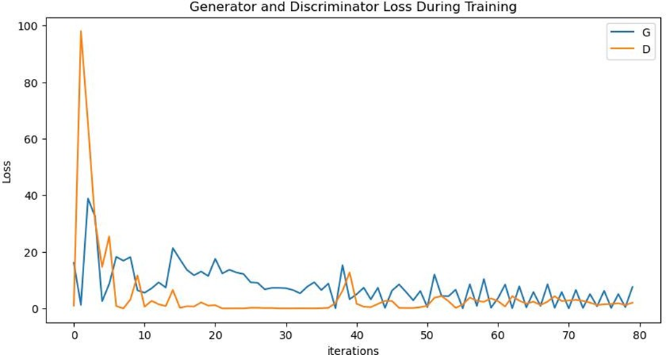

**After using the gray scale and made the layers simple , the loss may look like this[y-axis]**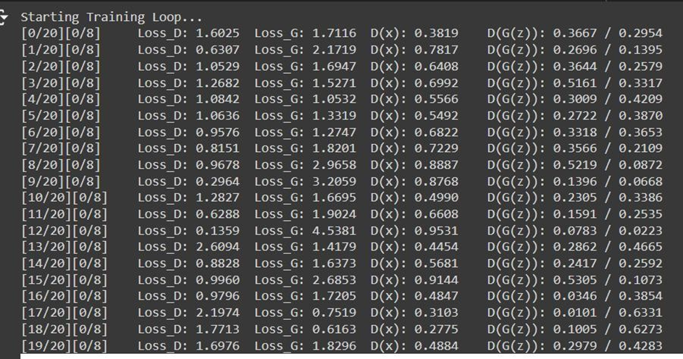

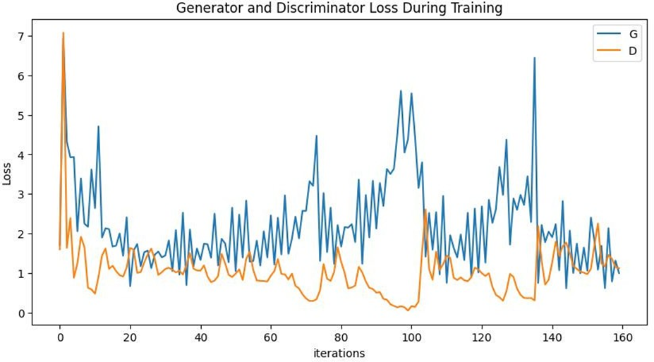

**These are the real and fake images after the training process is completed in grayscale**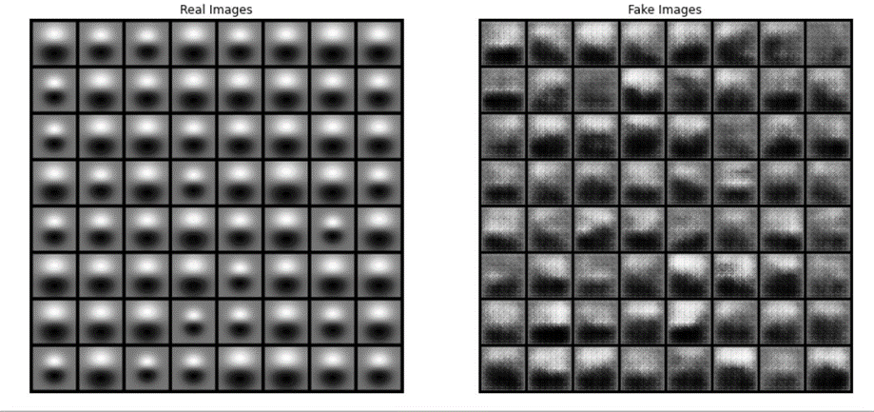

**I have tried to still reduce the loss taking** [**https://arxiv.org/pdf/1701.07875**](https://arxiv.org/pdf/1701.07875) **as reference and below are the results for the same**

**gradient Penalty Implementation :Gradient penalty enforces the gradient norm of the discriminator's output with respect to its input to be close to 1, which improves the training stability.**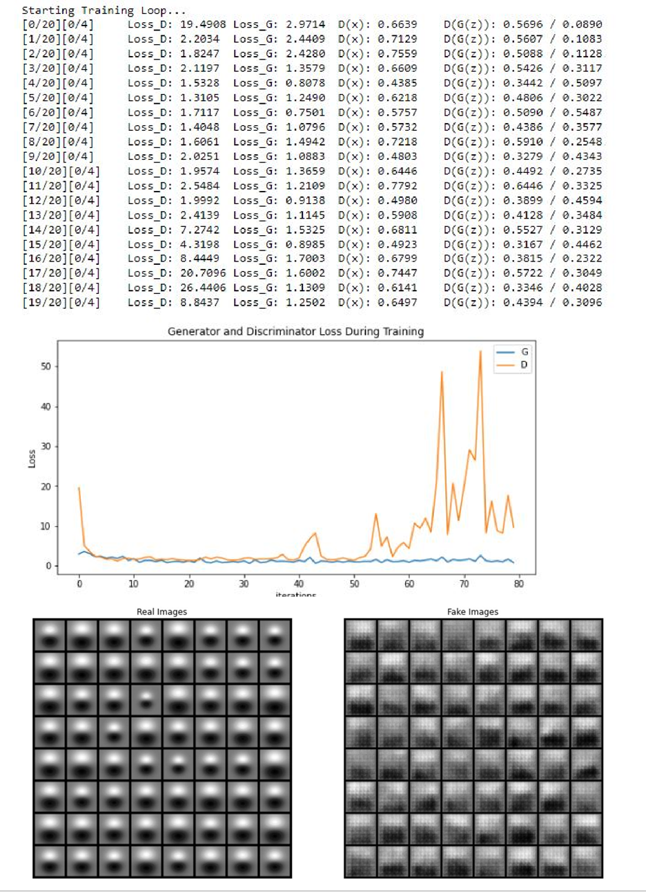

**These are the results when I use early stopping with patience 10 and 40 iterations**

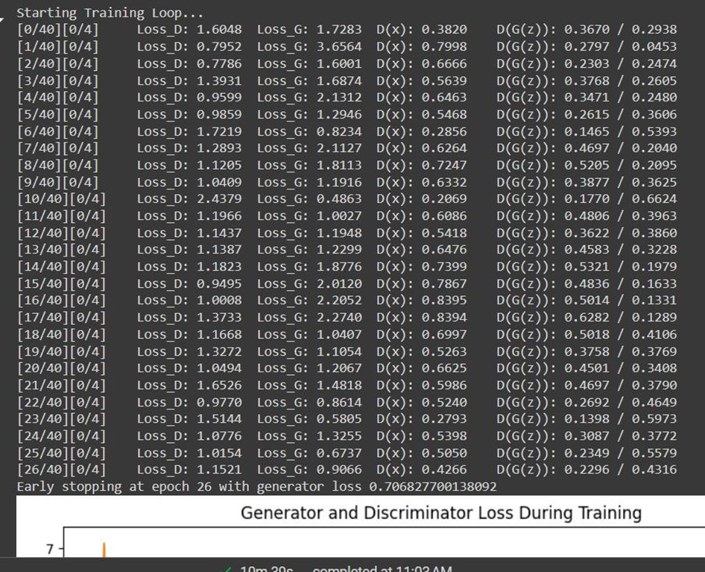

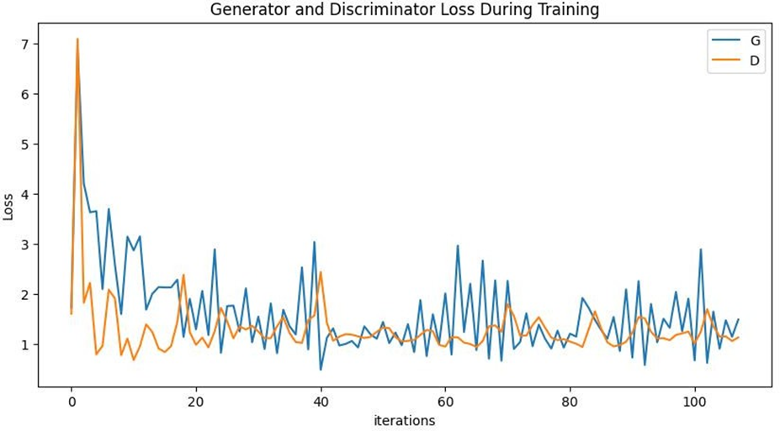

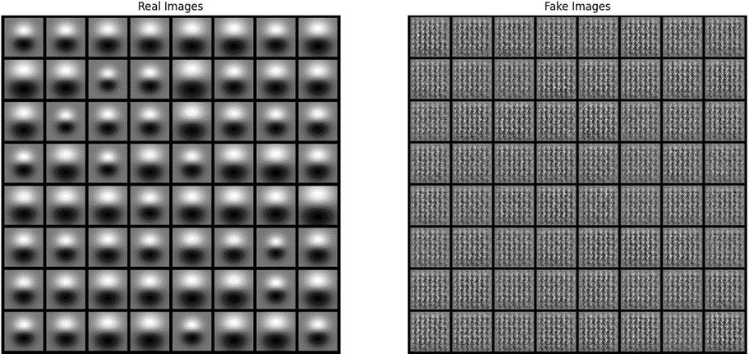

Below I have attached some best pictures (plots) but every plot along with all the trails of the plots are included in the code.